PROBLEM SET 2

QUESTION 1: RANDOM VARIABLES AND NORMAL DISTRIBUTION

In statistics, events which depend on chance are called random variables. As an example, we can consider a coin toss. Before the coin toss, nobody knows whether the result will be heads or tails. Hence, the coin toss is a random variable with two possible outcomes (ie: realizations), heads or tails. There are two possible realizations in this case. Two is a finite, number. Random variables with a set of finite possible realizations are called discrete random variables. So the coin toss is a discrete random variable.

Some random variables in nature have a continuum of possible outcomes, instead of just a finite number. As an example, you can consider the height of an individual. On one end of the spectrum, there are individuals like Taco Fall (NBA player, Boston Celtics Center) who is 7 ft 5 in tall. On the other hand of the spectrum, there are individuals like Peter Dinklage (the outstanding actor who played Tyrion Lannister in Game of Thrones) who is 4 ft 4 in tall. In between, there are billions of people with every imaginable height. Hence, height as a random variable has a continuum of possible outcomes. Random variables with a continuum of possible outcomes are called continuous random variables.

In nature, several continuous random variables follow what is called a normal distribution. Examples include height, weight, intelligence scores (IQ), blood pressure of humans, SAT scores and several more. The normal distribution can be found in the figure below:

Figure 1: Normal Distribution

The normal distribution is also known as the Gaussian Distribution, named after the famous German mathematician Carl Friedrich Gauss. You can find a picture of Gauss on the back of the German 10-mark banknote (Deutsche Mark) down below:

Figure-2: The German 10-Mark Banknote

Please note the normal distribution on the left-hand side of the 10-mark banknote.

The normal distribution has been extensively studied over the centuries and we know a great deal about it. For instance, we know that if a continuous random variable follows the normal distribution, 34.2% of all realizations will be between the mean and mean plus one standard deviation of the distribution. As an example, 34.2% of all individuals have a height between the mean height and mean plus one standard deviation in the United States. Referring back to Figure-1, you can see which percentage of the society will have a height between which numbers.

Given the information above, please answer the following questions:

- What is your height? Which percentage of the height distribution do you happen to be in?
I am 6ft tall
6×12=72inches
Therefore, 72inches is greater than the 1st deviation, and it lies in the 13.6% region in the height distribution.
Hint: The mean height for women in the US is 5 ft 4 in and the standard deviation of the height distribution for women is 2.5 inches.
The mean height for men in the US is 5 ft 9 in and the standard deviation of the height distribution for men is 3 inches.

- Watch Peter Dinklage give an acting master class in the following video:
https://www.youtube.com/watch?v=e4Uq8O5ZhUA (Links to an external site.)
Peter Dinklage won several awards for that great performance. In his own words, Dinklage’s character was “…guilty of being a dwarf.” and he was on trial for that reason alone. Remembering that Dinklage is 4 ft 4 inches, which percentage of the height distribution does he happen to be fall into?
Dinklage is 4feet 4inches
4×12 + 4= 52inches
The value is found beyond the -3 St. Deviation in the 0.1% region; therefore, it is an outlier.

1.Your instructor’s favorite NBA player is Jimmy Butler, aka Jimmy Buckets. Butler is the shooting guard for Miami Heat and 6ft 7in tall. Which percentage of the height distribution does Butler fall into?
Butler is 6feet 7inches tall
6×12+7=79inches
79inches falls beyond 3 St. Deviation in the 0.1% region on the right side, and therefore, it is an outlier

1.Your instructor is 5 ft 3 inches tall. What percentage of the height distribution does your instructor fall into?
The instructor is 5ft 3 inches tall
5×12+3=63inches
- 63inches is on -2 St. Deviation line,13.6% region.

1.The height distribution does not remain constant over time. The mean height for both women and men increases over decades. If we go back thousands of years in time, we can see that individuals used to be significantly shorter. As an example, archeological remains from the Mesolithic (10,000 years ago) indicate that women’s average height was around 5 ft 1 inch and men’s average height was around 5 ft 5 inches at the time.
Suppose you find a time machine and travel back in time 10 thousand years. What percentage of the height distribution would you fall into? (Hint: You can assume a standard deviation of 2.5 inches for women and 3 inches for men.)
If an individual travel backward up to 10,000 years from now
For men = 5ft 5inches
5×12 + 5 inches = 65in; = 3inches
For woman
= 5ft 1in
5×12 + 1 inches = 61in; = 2.5i

1.The height distribution is not the same across countries either. As an example, in Indonesia the average height of men is 5 ft 2 inches, and the average height of women is 4 ft 10 inches.

Suppose you travel to Jakarta, capital of Indonesia. What percentage of the height distribution would you fall into? (Hint: You can assume a standard deviation of 2.5 inches for women and 3 inches for men.)
I am 6ft
6×12=72inches
72inches falls beyond the 3rd. deviation in the 0.1%region on the right side, and it is an outlier
QUESTION 2: SETTING UP CONFIDENCE INTERVALS
Confidence intervals are used in practice frequently for quality control purposes. As an example, you can consider a factory that produces tens of thousands of bottles of soda every day. Suppose that each bottle of soda is supposed to contain exactly 1 kilogram (ie: 1,000 grams) of soda. Since machines are not perfect, not every single bottle will have exactly 1,000 grams of soda. Some of the bottles will have more than 1,000 grams and others will have less than 1,000 grams of soda.
Ideally, the factory which produces these bottles of soda would like to measure the amount of soda in every bottle and discard the bottles that have either too much or too little soda. But it would take too much time, effort, and money to measure the amount of soda in every bottle.
As a solution to this problem, almost a century ago the British statistician, Ronald Fisher offered the following methodology:

Step-1: Take a random sample of a reasonable size. It can be a random sample of 10, 15, 20, 25 bottles etc. from the production line.
Random sample size=20
1014 992 984 1007 990 994 1010 1005 994 994 1001 1001 1016 1012 1025 997 983 1017 999 1014
Step-2: Measure the amount of soda in every bottle in the sample. Using these observations calculate the average and the standard deviation of the amount of soda in the bottles in the sample. Also calculate the standard error of the sample by dividing the standard deviation with the root square of the number of bottles in the sample.
Mean=1002.45
Sd=11.673
Std.err=sd/√20=2.61
Step-3: Calculate the lower bound of the confidence interval:
Mean of the sample minus (critical value for the desired confidence level times the standard error of the sample)
95% con interval
^{t}cr, df=190.025
=2.093
lower boundary=1002.45+2.093× (2.61)
=996.9873
Step-4: Calculate the lower bound of the confidence interval:
Mean of the sample plus (critical value for the desired confidence level times the standard error of the sample)
1002.45+2.0932.093×(2.61)=1007.913
Step-5: Interpret the confidence level that you just set up.
These results (996.9873,1007.913) ascertain that the true mean level of soda amount filled by the machine is contained inside these intervals.
With this methodology, if the desired confidence level is 95%, Ronald Fisher says that we can expect 95% of all the bottles filled in the factory to have an amount of soda that will be between the lower bound and the upper bound of the confidence interval which you calculated.

For a picture of Ronald Fisher, see Figure-3 below:

Figure-3: A young Ronald Fisher in 1913. The F distribution in statistics is named after Fisher

One thing we should keep in mind is that the confidence interval we set up is sensitive to the random sample of bottles we picked up from the production line. Hence, with each different random sample, we would calculate a different lower bound, and a different upper bound for the confidence interval. This will be important later. Please make sure to keep it in mind.

Now we will make use of the information above.

1.Suppose you pick a random sample of 15 bottles of soda from the production line in a soda factory. The bottles in the sample contain the following amounts of soda:

Bottle 1: 975 grams
Bottle 2: 985 grams
Bottle 3: 990 grams
Bottle 4: 981 grams
Bottle 5: 996 grams

Bottle 6: 1014 grams
Bottle 7: 998 grams
Bottle 8: 1004 grams
Bottle 9: 1024 grams
Bottle 10: 995 grams

Bottle 11: 1002 grams
Bottle 12: 1000 grams
Bottle 13: 999 grams
Bottle 14: 969 grams
Bottle 15: 1018 grams

Enter this data into Excel. Using Excel, calculate the average amount of soda in the bottles in this sample. Next calculate the standard deviation of the amount of soda in the bottles in the sample using Excel. Finally, divide this standard deviation with the root square of 15 (ie: sample size) to calculate the standard error of the sample again using Excel.

1.Assume a 95% confidence interval. The critical value we can use to set up the 95% confidence interval is 1.96. Calculate the lower bound and upper bound of the confidence interval.
If the CL=95% the Z value is 1.96
CL=xbar+/-Z×S/sqrt(n)
996.67+/-1.96×15.28/sqrt (15)
=996.67+/-7.7327
ANSWER= (988.94,1004.40)

1.After you set up the confidence interval, interpret the result.
It can be concluded that 95% interval lies between (988.94,10040)
QUESTION-3: HYPOTHESIS TESTING

The idea of hypothesis testing in statistics is closely related to the concept of confidence intervals. We can use hypothesis testing to either validify or refute an idea by using the limited data that is available after random sampling from a population.

So, what are the mechanics of hypothesis testing? The methodology can be summarized by the following steps:

Step-1: Determine whether the hypothesis being tested requires a one sided or a two-sided test. In our lectures we discussed how we can do a two-sided test. So below you will find a question where you will do a two-sided test. But doing a one-sided test is just as simple.
The hypothesis being tested requires a two sided test.
Step-2: Write the null hypothesis. This is the hypothesis that we will test. In the end, we will either reject or fail to reject this null hypothesis.
The null hypothesis is H_{o} - = 10.
Step-3: Write the alternative hypothesis. The burden of proof is always on the alternative hypothesis. So we begin with a position where we assume the null hypothesis is correct and then try to see whether we can reject the null hypothesis with the available data.
The alternative hypothesis is H₁ - 10.
Step-4: Set up the test statistic required for hypothesis testing. The test statistic is equal to:

[Sample average – value we are testing in the null hypothesis] / standard error of the sample
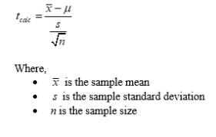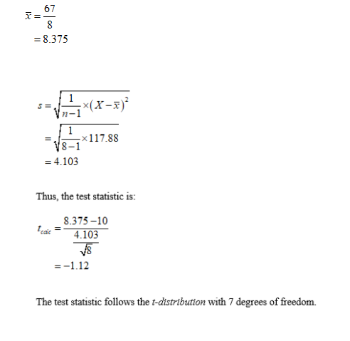
Step-5: Find the critical value that is associated with the desired confidence level. Please note that this critical value will depend on the sample size and the chosen confidence level. If the sample size is less than 30 observations, you will have to look up the critical value from the t -distribution table.
t-distribution tables with one and two tails can be found here:
https://www.statisticshowto.com/tables/t-distribution-table/ (Links to an external site.)

If the sample size is greater than 30 observations, you can look up the critical value from standard normal distribution table, which can be found here:
https://www.math.arizona.edu/~jwatkins/normal-table.pdf
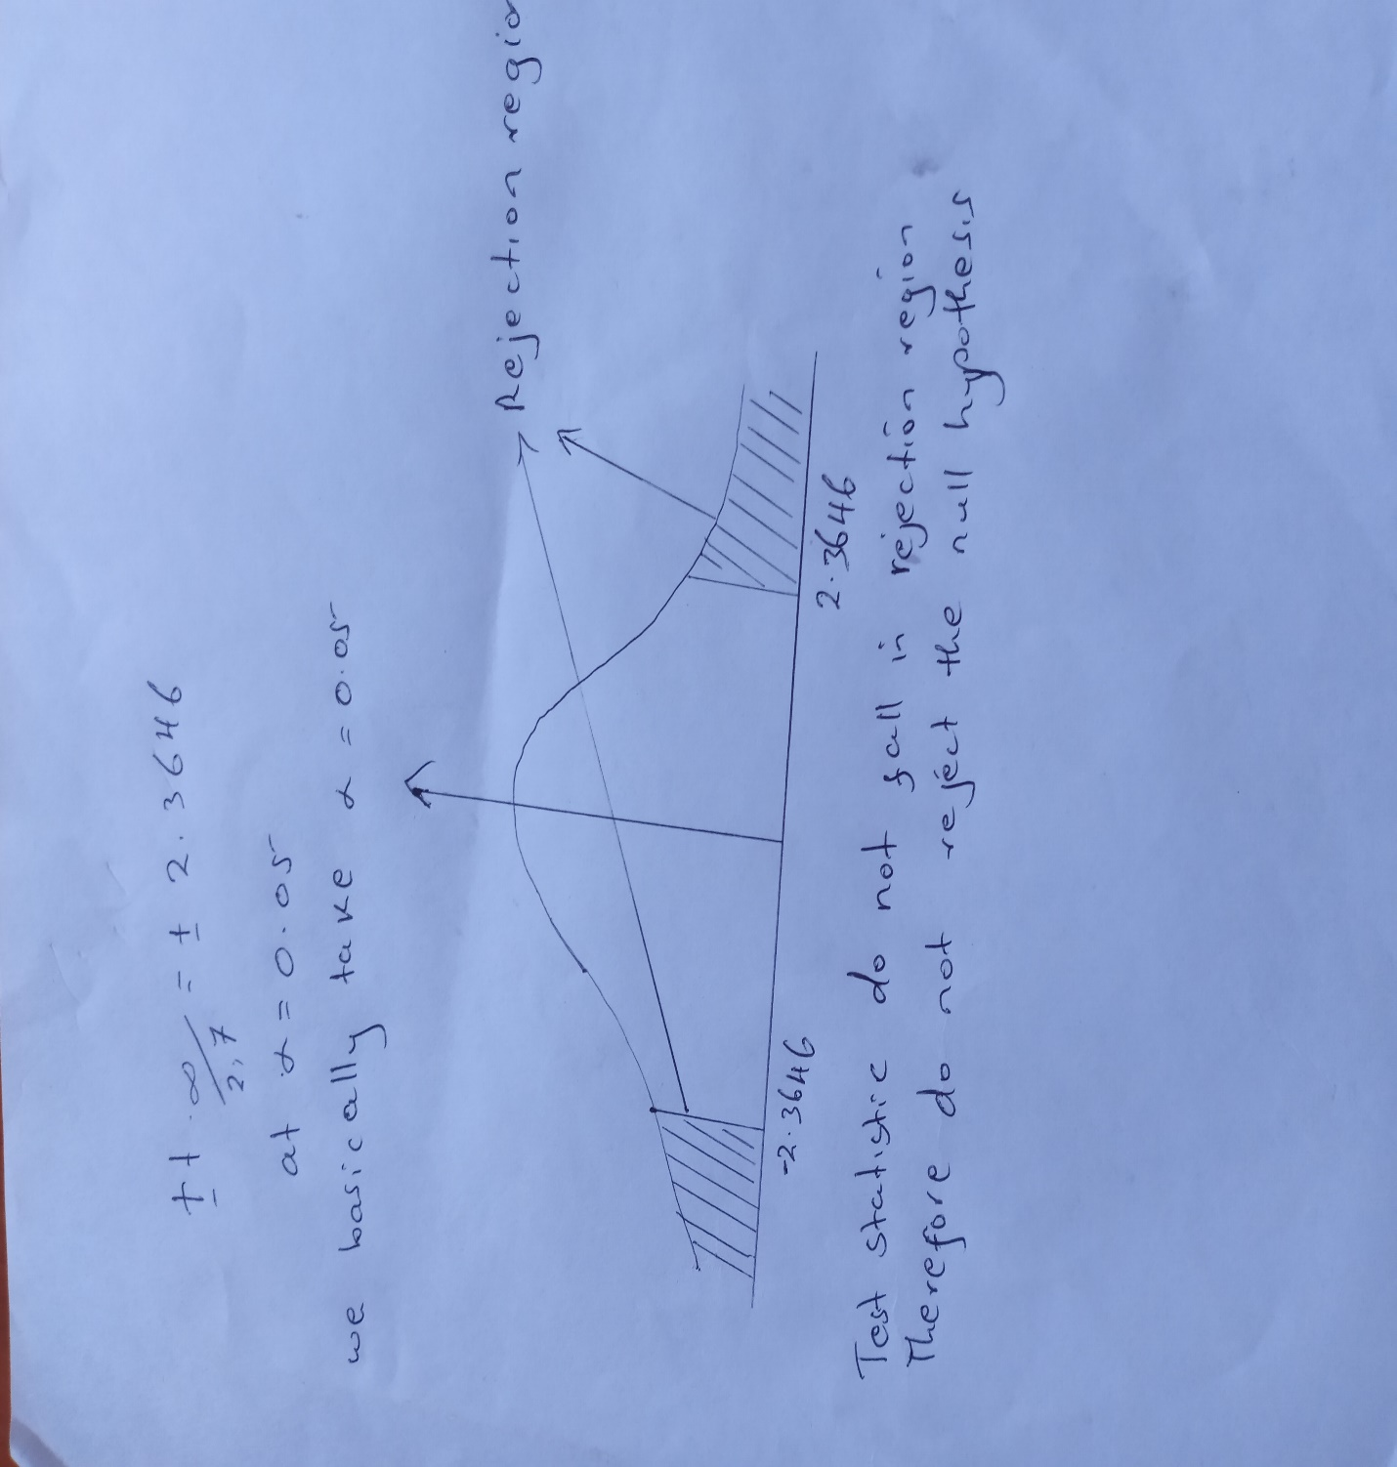

Step-6: Compare the test statistic with the critical value. If the test statistic is greater than or equal to the critical value, we reject the null hypothesis. If it is less than the critical value, we fail to reject the null hypothesis.
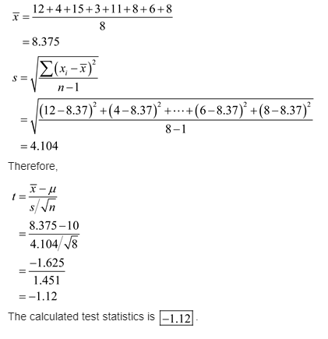
Step-7: Interpret the result and state the probability of making a type I or a type II error. Type I error in statistics is the probability of rejecting a hypothesis we should not have rejected. Type II error is the probability of not rejecting a hypothesis we should have rejected.
Since P-value is less than significance level 0.10, we reject the null hypothesis.
Decision: Reject Ho.
Conclusion: There is sufficient evidence to conclude that the mean number is different from ten.

Please keep in mind that the test statistic we calculate depends on the random sample we select from the population. Hence, it can be the case that we reject a null hypothesis with the test statistic we calculate by using one random sample. Yet with another random sample and the test statistic we calculate by using that random sample, we might fail to reject the same null hypothesis.

When we fail to reject a null hypothesis with a random sample at the 95% confidence level, this should be interpreted as follows: If we do this random sampling experiment many times, 95% of the time the test statistic we calculate will be either bigger than or equal to the critical value associated with the desired confidence level. But 5% of the time the random samples we collect will give us a test statistic that will be less than the critical value.

Hence, if the value being tested in the null hypothesis is correct and if the confidence level of the test is 95%, there is a 5% chance we will be making a Type I error if we fail to reject the null hypothesis.

Similarly, if the value being tested in the null hypothesis is wrong and if the confidence level is 95%, there is a 5% chance we will make a Type II error if we reject the null hypothesis.

Now, we will make use of the information above in the following question:

The mean number of sick days an employee takes per year is believed to be about ten. Members of a personnel department do not believe this figure. They randomly survey eight employees. The number of sick days they took for the past year are as follows: 12, 4, 15, 3, 11, 8, 6, 8. Let x = the number of sick days they took for the past year. Should the personnel team believe that the mean number is ten? Use the steps int the pages above to test the null hypothesis of whether the mean number is equal to 10.
The mean number of sick days by eight employees last year was found to be eight and the standard deviation 1.1
n = 8, = 8, s = 1.1
testing of the mean for 10
Hypothesis -
H_{o} - = 10, i.e., the mean number of sick days is equal to 10.
H₁ - 10, i.e., the mean number of sick days is not equal to 10.
Test statistic -
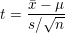
Test criterion -
Calculations -
Here, n = 8, = 8, = 10, s = 1.1
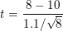
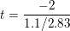
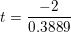
Critical value -
t_{/2, n-1} = t_{0.05/2,8-1} = t_{0.025,7} = 2.3646
Result -
Here, t (-5.1427) < -t_{/2, n-1} (-2.3646), hence H_{o} is rejected at 5% level of significance.

